VPC challenge
Use Case: Setting up Transit Gateway and VPC Endpoints for a Multi-VPC Architecture
Scenario:
A large organization is migrating its on-premises infrastructure to the AWS cloud.
The organization's architecture involves multiple VPCs for different departments and applications, each requiring secure communication with centralized services and external resources.
The IT team needs to design and implement a scalable and efficient network architecture to accommodate the organization's growth and ensure robust connectivity between VPCs and external services.
Objectives:
- Design and deploy a scalable network architecture using AWS Transit Gateway to simplify network connectivity between multiple VPCs.
- Configure VPC endpoints to securely access AWS services without internet gateways or NAT gateways, ensuring data privacy and minimizing exposure to external threats.
For create transit gateway we create 4 vpc with 1 public subnet and 1 private subnet.

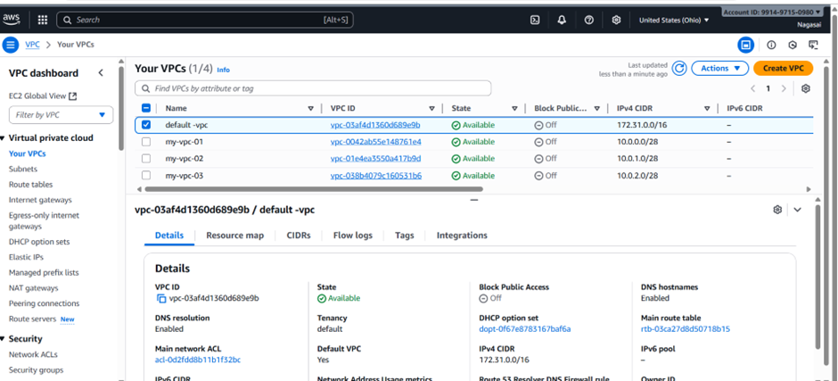
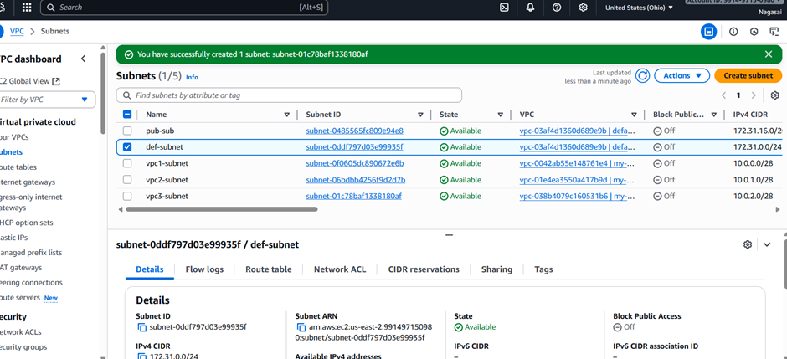

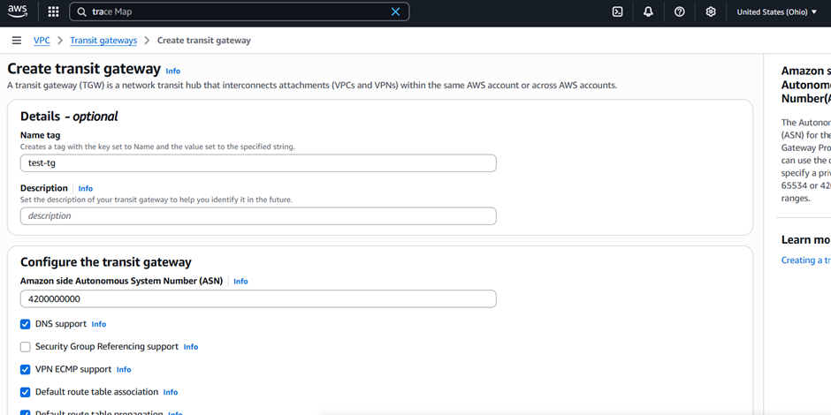

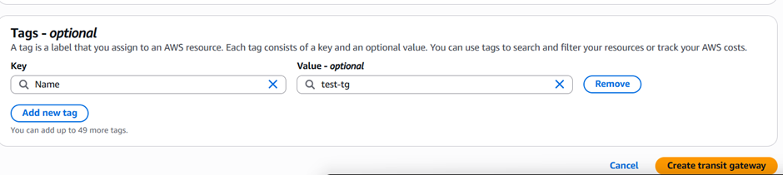
Now go to transit gateway attachments and create 4 attachments for 4 vpc.

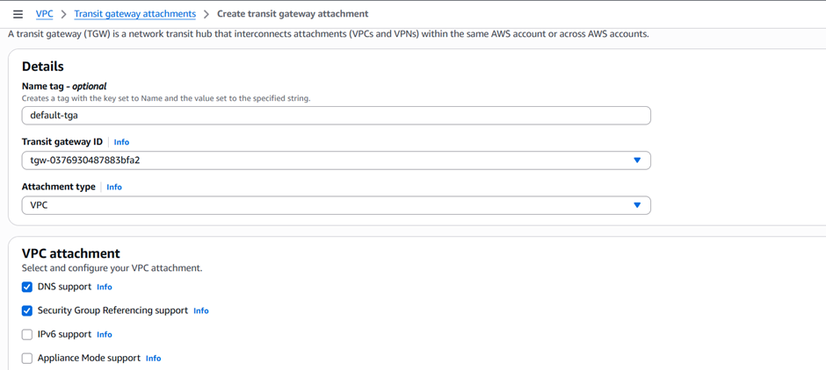

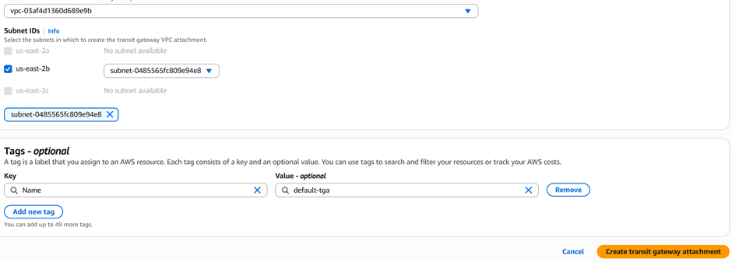
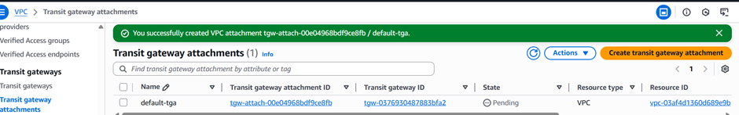
Similarly, we attached transit gateway attachments to remaining vpc’s
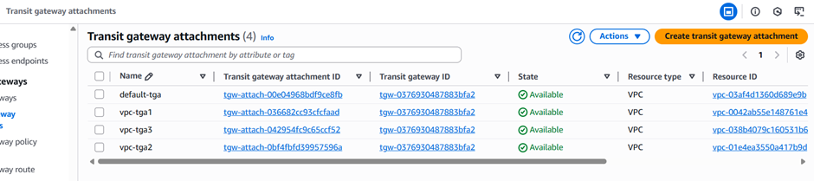
By default it will create transit gateway route tables.
Now, launch 4 ec2 instances in public subnets

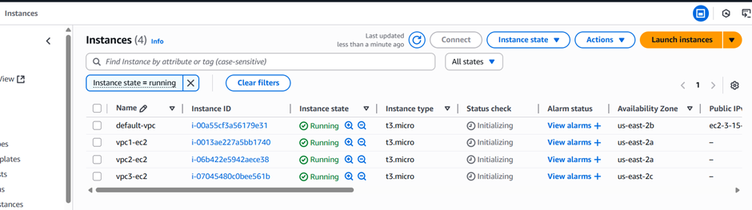
Now, go to routes of 4 vpc and add all the CIDR range in routes with transit gateway. And also add internet gateway

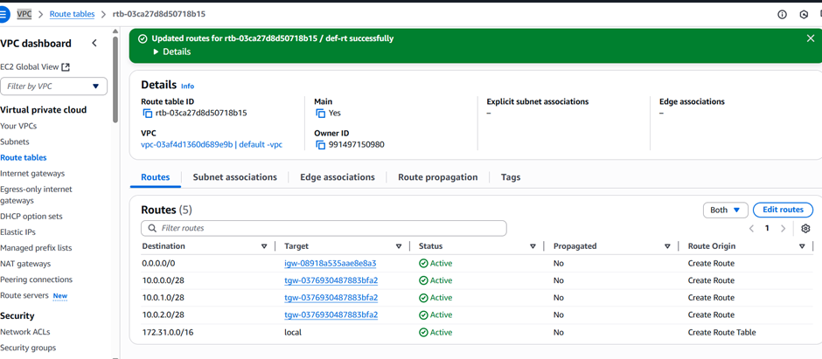
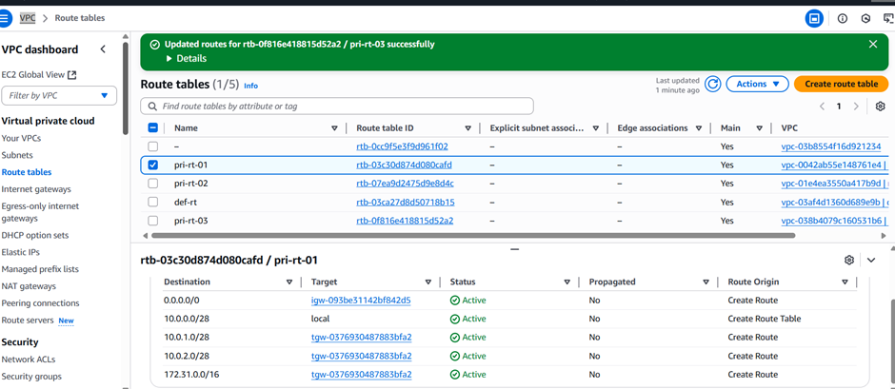

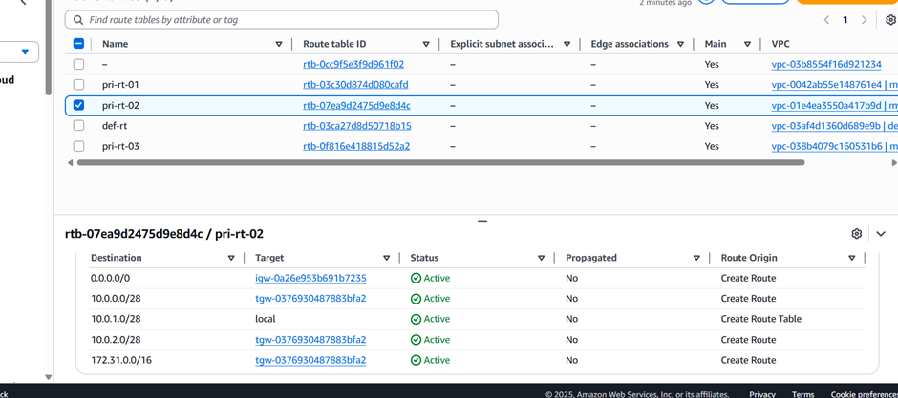
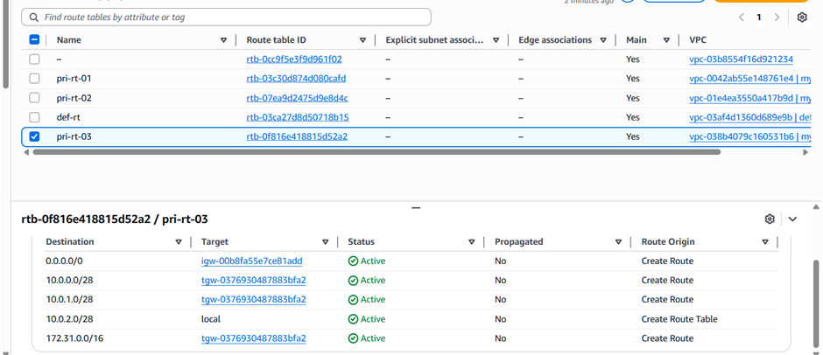
And also updated the security group with all traffic open.
Now connect to public ec2user and ping second private ip of ec2 instance using ping command.
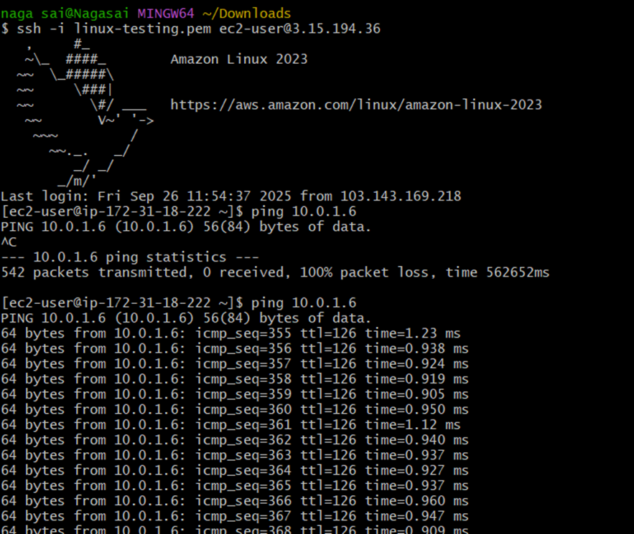
Vpc end point is used to connect aws resources internally without internet connection.
Now go to create end point service.
Go to vpc→ end points→create end point.
Select aws services and search for s3 and use s3 end point service.
In network settings → attach vpc and select private route table and click on create end point.
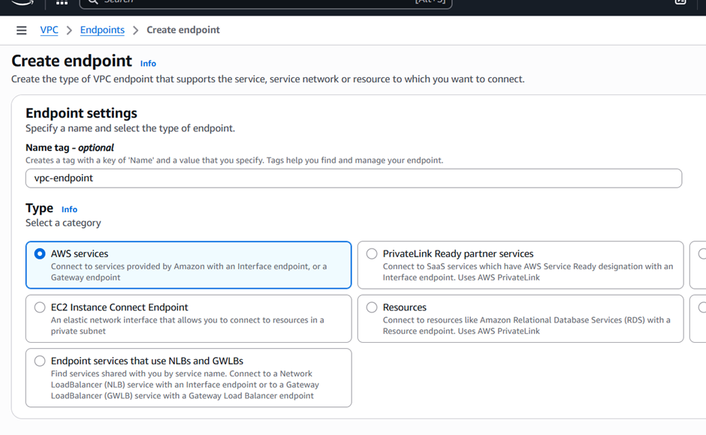
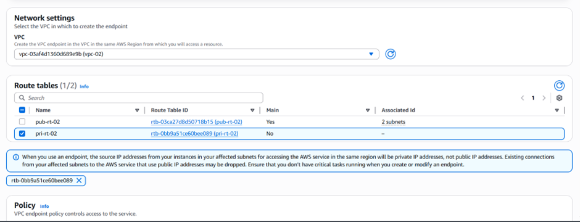
Now, successfully created end point service
Also, updated the route table to particular end point and this endpoint is mapped with s3.
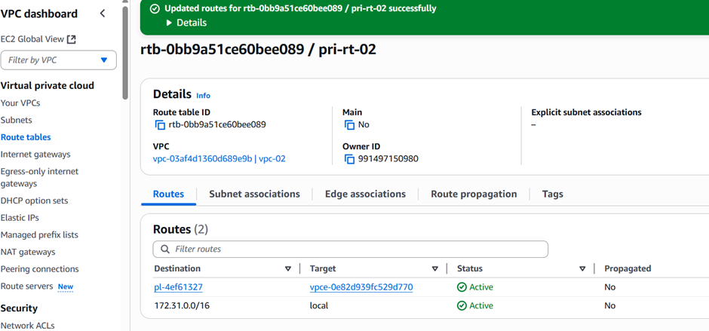
Now try to access s3 with private ec2 and this will work
